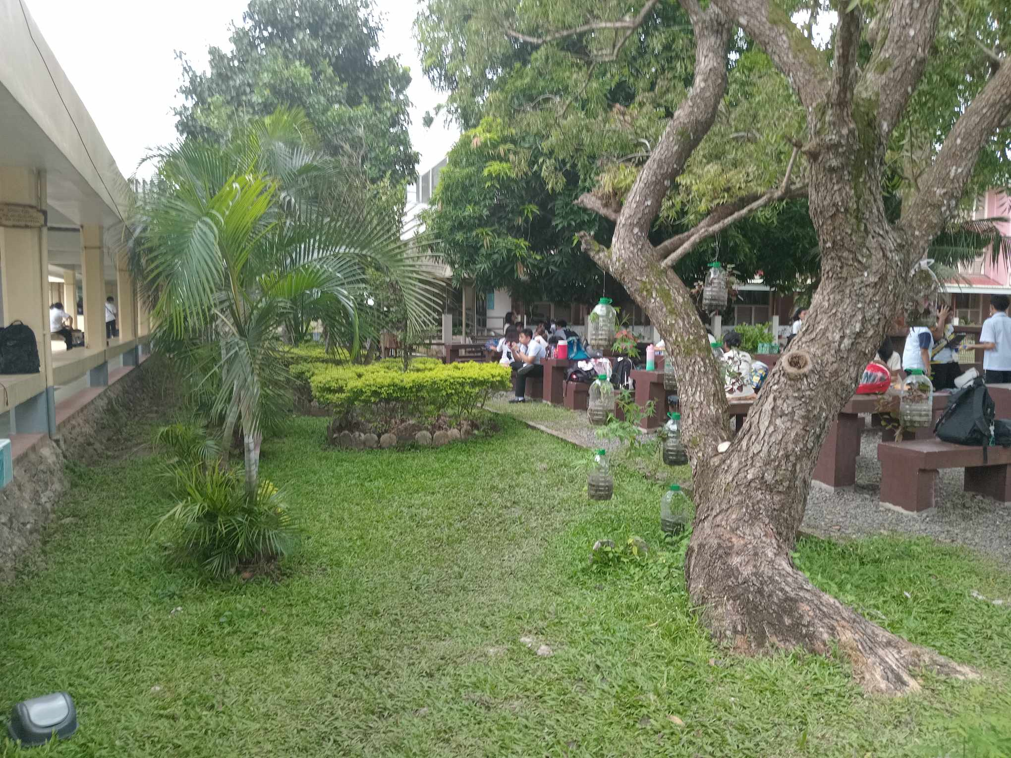

**Organization:**  
This image shows this theme because there are many different levels of the biological organization shown in just this one picture. Firstly, the students on the side make up a population, as they are all humans and are therefore of the same species. Next, all of the plants within the image, such as the trees and the grass, form a community because, although they are all plants, they are all different species of plants. Lastly, when combining biotic factors, which are the plants and the humans, as well as the abiotic factors, such as the temperature, it all comes together to form one small ecosystem.  
  
**Information:**  
This theme is shown through the differing appearances of the many people that are within the image. Every person comes from different sets of parents, which causes them to all look different from one another due to inheriting completely different sets of genes. This shows the theme of information because the differing sets of DNA all hold different sets of information in the genes which causes each person to look different  
  
**Energy and Matter:**  
The trees, grass, all other plants, as well as the people within the image are showing the theme of energy and matter. The plants are actively absorbing the sunlight in the process of photosynthesis to create glucose for them consume and turn into energy. The people are actively using energy externally whilst moving around the benches, as well as internally because of the body’s own processes that happen involuntarily, such as the pumping of blood around the body.

**Interactions:**  
The theme of interaction is shown in this image through the plants that have different symbiotic relationships. One example is the plants that are in the plastic containers that are hanging from the tree; the plants have a place to grow thanks to the tree and are gaining something from this, while the tree is left completely unaffected, which is an example of commensalism. Another example would be the many bush plants that were planted within the same area, because they share the same small area, they are constantly competing for nutrients to allow them to grow.

**Evolution:**Each and every living organism within this image is the living proof of evolution. The plants and the people all came from one common ancestor, known as Luca, and that one unicellular organism created offspring and the offspring continuously evolved for many millennia until they got to get to where we are now. Us humans, along with the plants, are the proof of the theme of evolution.